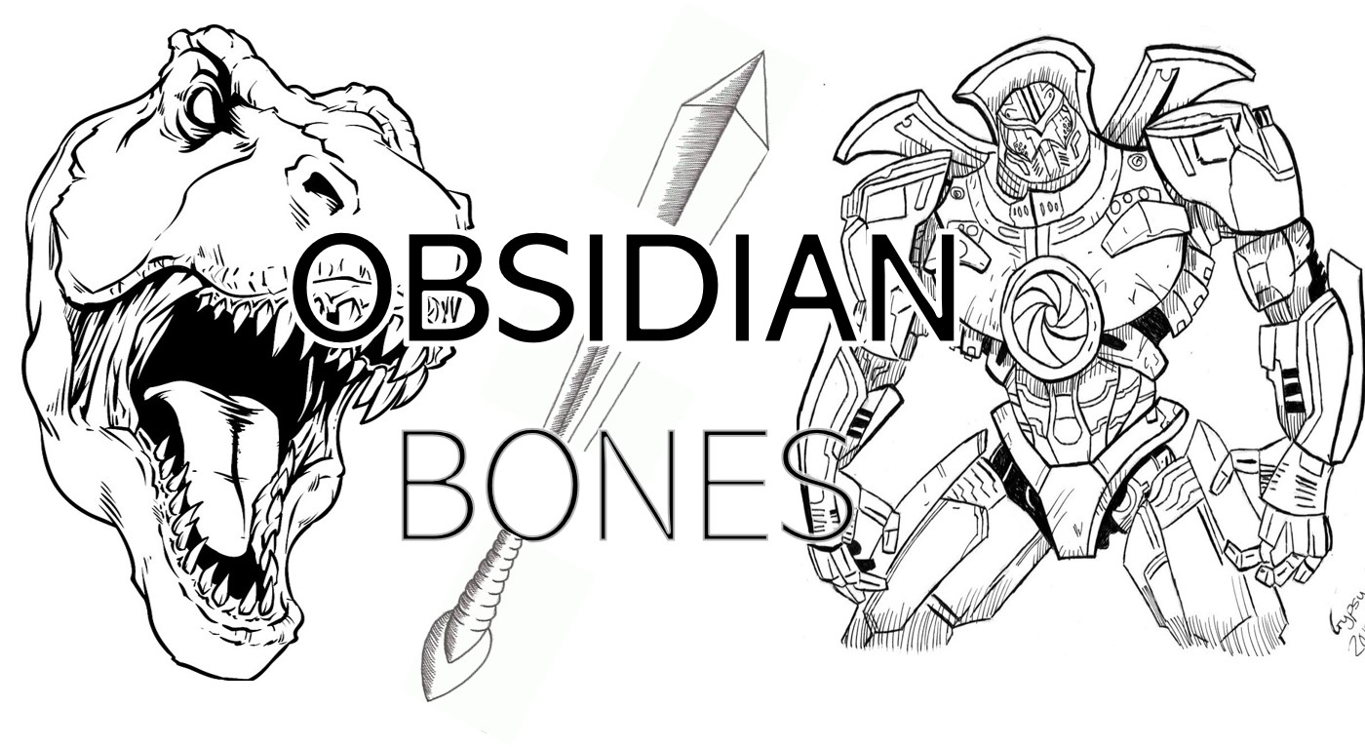

Game Pitch Document

Team 5

SPACKE Games

Obsidian Bones

09/23/2020

Version 1.0

**Table of Contents**

Executive Summary 3

High Concept 3

Core Gameplay: Mechanics and Dynamics 3

Core Gameplay Aesthetic 3

Look and Feel Aesthetic 4

Genre, Platform, and ESRB 6

Audience and Targeted Customers 6

Game Differentiators/Unique Selling Points 6

# Executive Summary

## High Concept

Obsidian Bones is a rouge-like action platformer where you have to time travel through different eras to save the world. Slash and blast through each stage, picking up enemies’ loot and upgrading your skills along the way. Face foes from various time periods and beat each stage’s boss to advance.

## Core Gameplay: Mechanics and Dynamics

Fight through each era to save the planet and humanity from their most perilous foes. Use your sword and daggers to defeat enemies on your path before confronting their respective boss. Upgrade those weapons after each era to evolve and become stronger.

The game uses the following mechanics: As the hero you can move left or right, jump, shield, pick up items, and use your skills to kill enemies. Your first skill has no cooldown and consists in swinging/stabbing with your sword (M1). Your other skill has a 2 seconds cooldown and consists in throwing your daggers for long-range damage (M2). Killing enemies drops items that you can pick up to either regenerate your life as your fighting or later use to improve your health and skills. You have a better chance of defeating the final boss with more items which help you get those improvements. Jumping is used to dodge enemy attacks and to move more smoothly through the levels. Another method to defend yourself against enemies is to use shielding to parry attacks.

## Core Gameplay Aesthetic

aesthetics

As an action-based platformer in which the player travels through time, every time-period represented as stages in the game will have a different mood and invoke different feelings in the player. Overall, the game seeks to spark a sense of adventure and heroism in the player as he defeats enemies that have walked the earth throughout its history. In the stages that are set in earlier parts of history, ones in which a player has not lived through, the game aims to make use of the average player’s historical knowledge so the player can engage in fights against past evil actors in the world as if living vicariously through people of the past. As the stages progress, the world starts becoming bleaker as the inhabitants of the earth take a toll on the planet, and this seeks to invoke a sense of urgency in the player. He starts losing hope in the world as it declines before his eyes but he never stops trying to save it. Fighting enemies in the modern stage will have the player fighting for the current state of the earth as it is. In the final stage, the intensity of the game has reached its peak, while the earth’s health and future hangs in the balance. It is up to the player to save it, and although it is the most difficult to do so, it is also the most important. That sense of importance, as well as the fact that the player has now completed 4 other stages, empowers the player in spite of how hopeless it might seem. He must defeat tough and violent androids from a dystopian future, feeling fear but a sense of duty that pushes him to finally complete his mission of saving the earth from millions of years worth of earth’s most perilous foes.

## Look and Feel Aesthetic

The game is really trying to immerse the hero in each era to give the player a sense of progression and time traveling as he/she defeats the bosses and progresses through the eras. By having appropriate and characteristic backgrounds (and enemies) for each era (Pre-Historic, Middle Ages/Renaissance, WWII, Modern Era, Future/Robot Revolution) the player will be able to feel as if he/she is revisiting the past (looking back at history) for the first 3 levels, but will also get to experience a fantasy in the last level by being plunged into a futuristic world. An important detail to not neglect is that the hero will not change weapons nor clothes to fully give the player a time traveler’s perspective.

**Concept Art**



*Stage 4: Modern Era / Post WWII (1940 – 2100)*

Color scheme: dark blues, purples, grays

World becoming more bleak, hot and polluted

Emotions invoked: aggression, desire to keep fighting as hero

is losing hope but not completely



*Stage 5: Future / Mid to Post Robot Revolution [[ Final Stage ]] (2200 - ?)*

Color scheme: dark greys, mechanical – not nature tinted greens

Hot, barren and lifeless, dominated by technology run amuck

Emotions invoked: fear, cynicism. However, also empowerment as

the hero has come so far already and is so close to saving the earth

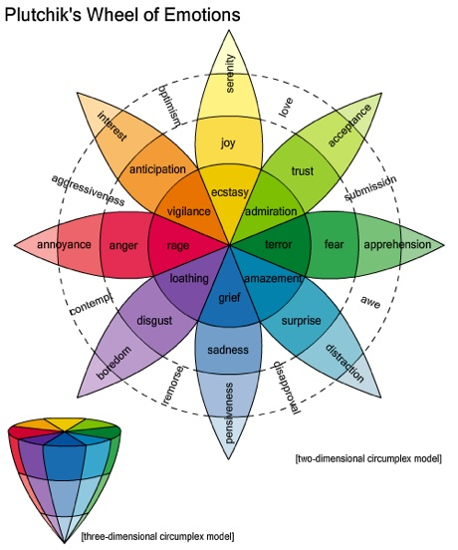



### Genre, Platform, and ESRB

This game will be browser-based. The expected ESRB rating is E10+. The game falls under the genres of action-adventure, rogue-like, platformer and role-playing.

### Audience and Targeted Customers

The target audience for this game primarily fits under the categories of ‘achievers’ and ‘explorers.’ This game is targeted at a solid middle ground between hardcore/casual gamers, as the game is single player and narrative-based, but still requires some mechanical skill to complete. Target players would primarily be young adults who enjoy action and adventure style games that do not focus too heavily on competition. Given the single-player nature, the persona of this game’s audience is as follows:

* Introverted
* Intuitive
* Thinking
* Judging

Motivations to play this game would involve the satisfaction of controlling a character with a clear hero’s journey laid before them and engaging in combat with defined strength progression and improvement. The mechanics and combat are fairly straightforward, giving players a fairly easy learning curve with a reasonable ceiling they can achieve and feel accomplished about.

## Game Differentiators/Unique Selling Points

* Time traveling plot progression through various epochs.
* Different enemies, settings, and bosses for each age.

## Current Status, Timeline and Costs

Current Status: Game Concept Phase

Alexander Chiu: 16

Kristina Salazar: 15

Edoardo Palazzi: 15

Total hours a week: 46

Total Cost of Project: (46 hrs/wk) * 13 weeks * $37.50 = $22.425

Signatures verifying agreement:

**Alexander Chiu**

**Kristina Salazar**

**Edoardo Palazzi**